# CS 255 System Design Document Template

## UML Diagrams

### UML Use Case Diagram

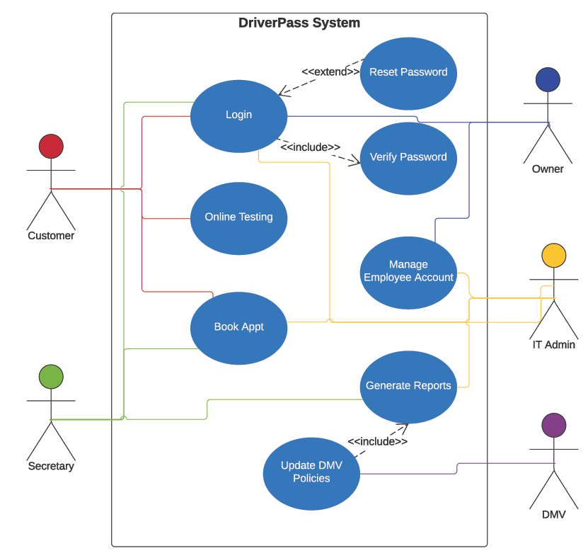

### UML Activity Diagrams

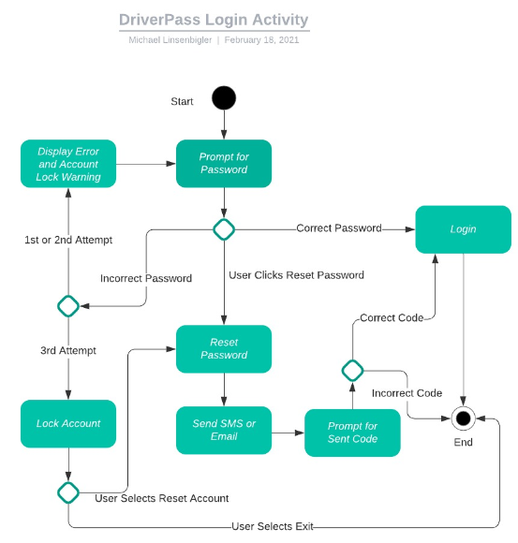

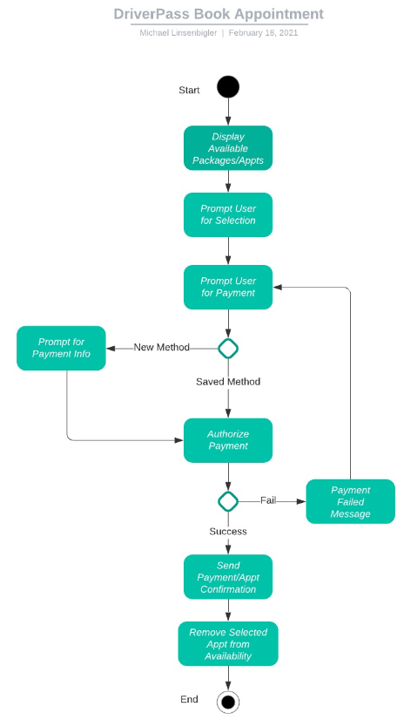

### UML Sequence Diagram

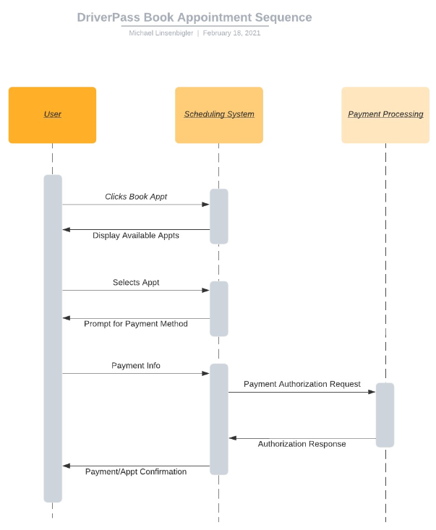

### UML Class Diagram

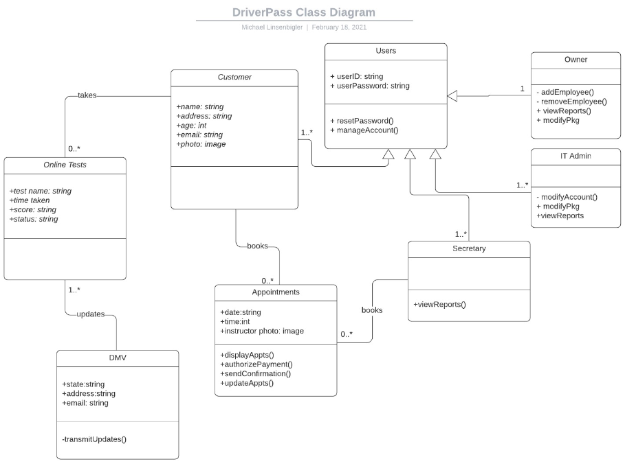

## Technical Requirements

***Hardware Requirements:***

* *Computers, screens, printers, phones, mouse, keyboard for all company employees*
* *Internet-connected device for customers to access online application*
* *Mobile devices and tablets for customer troubleshooting purposes*

***Software Requirements:***

* *Cloud-based computing services such as database, security, web-hosting, email*
* *OS and web browser for company computers*
* *Back office software (ex. Excel) for record keeping and formatting*

***Tools and Infrastructure Requirements:***

* *Internet service for the company location*
* *Phone service for the company location*
* *Payment processing service*